Technical Design Document

Project name: **Flight Booking System**

Project By: Shivam Prakashrao Hatwar

**Introduction**

Flight booking System is an application to meet the needs of online Flight reservation system, with 1 actor: i.e. User/Customer. The architecture implemented is Spring Boot using Spring boot and Angular framework. The proposed system is a solution for users to book flight tickets, search for tickets, view booking details and many more such features just by sitting at their home.

**Functional Requirements:**

The functional requirements of the project are:

**For the User:**

* Login/Register
* Search Buses
* Create Booking
* Make Payment
* View Bookings
* View Booking Details
* Cancel Booking

**Overall Architecture Diagram:**

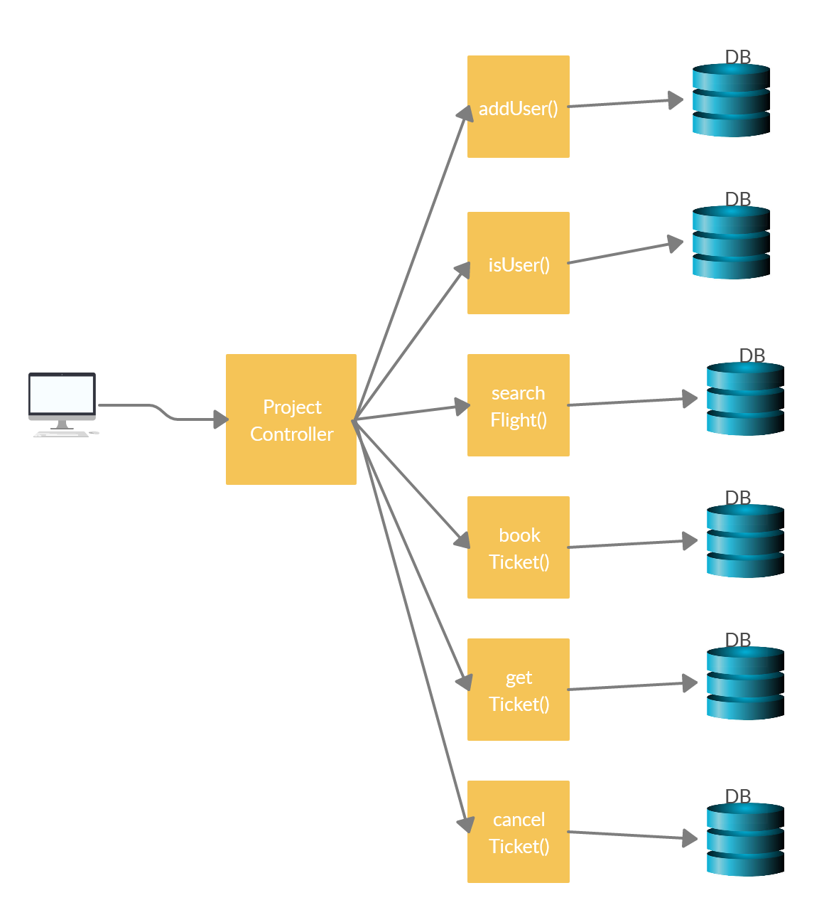

**Overall Entity Relationship Diagram:**

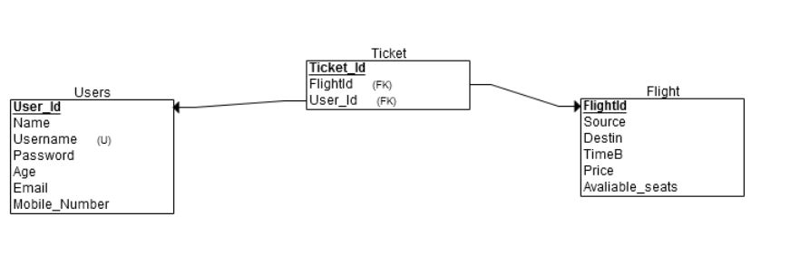

**Sequence Diagrams**

**Login:**

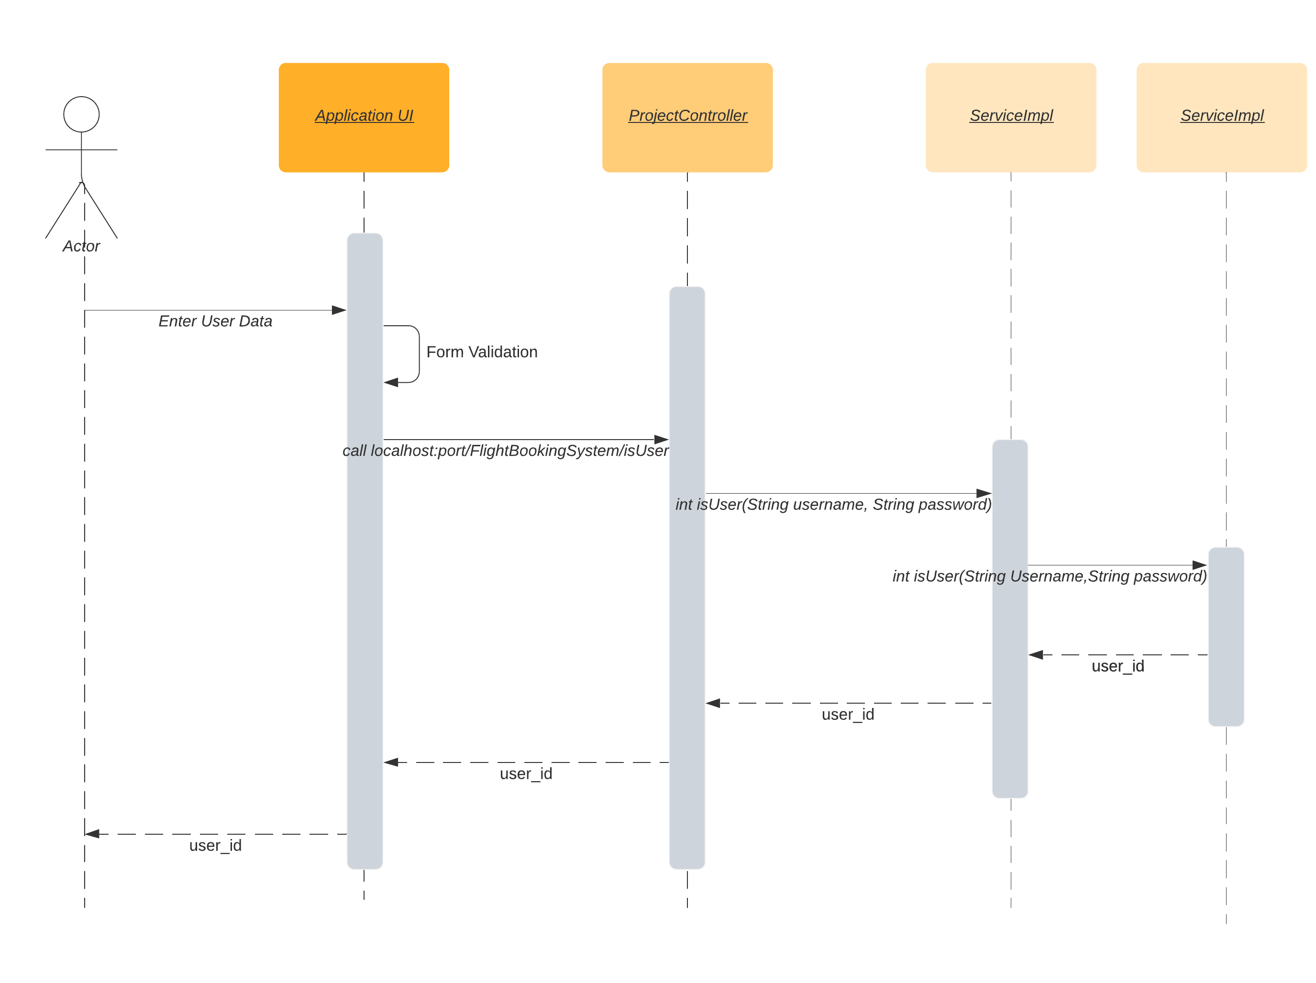

**Registration of new User -**

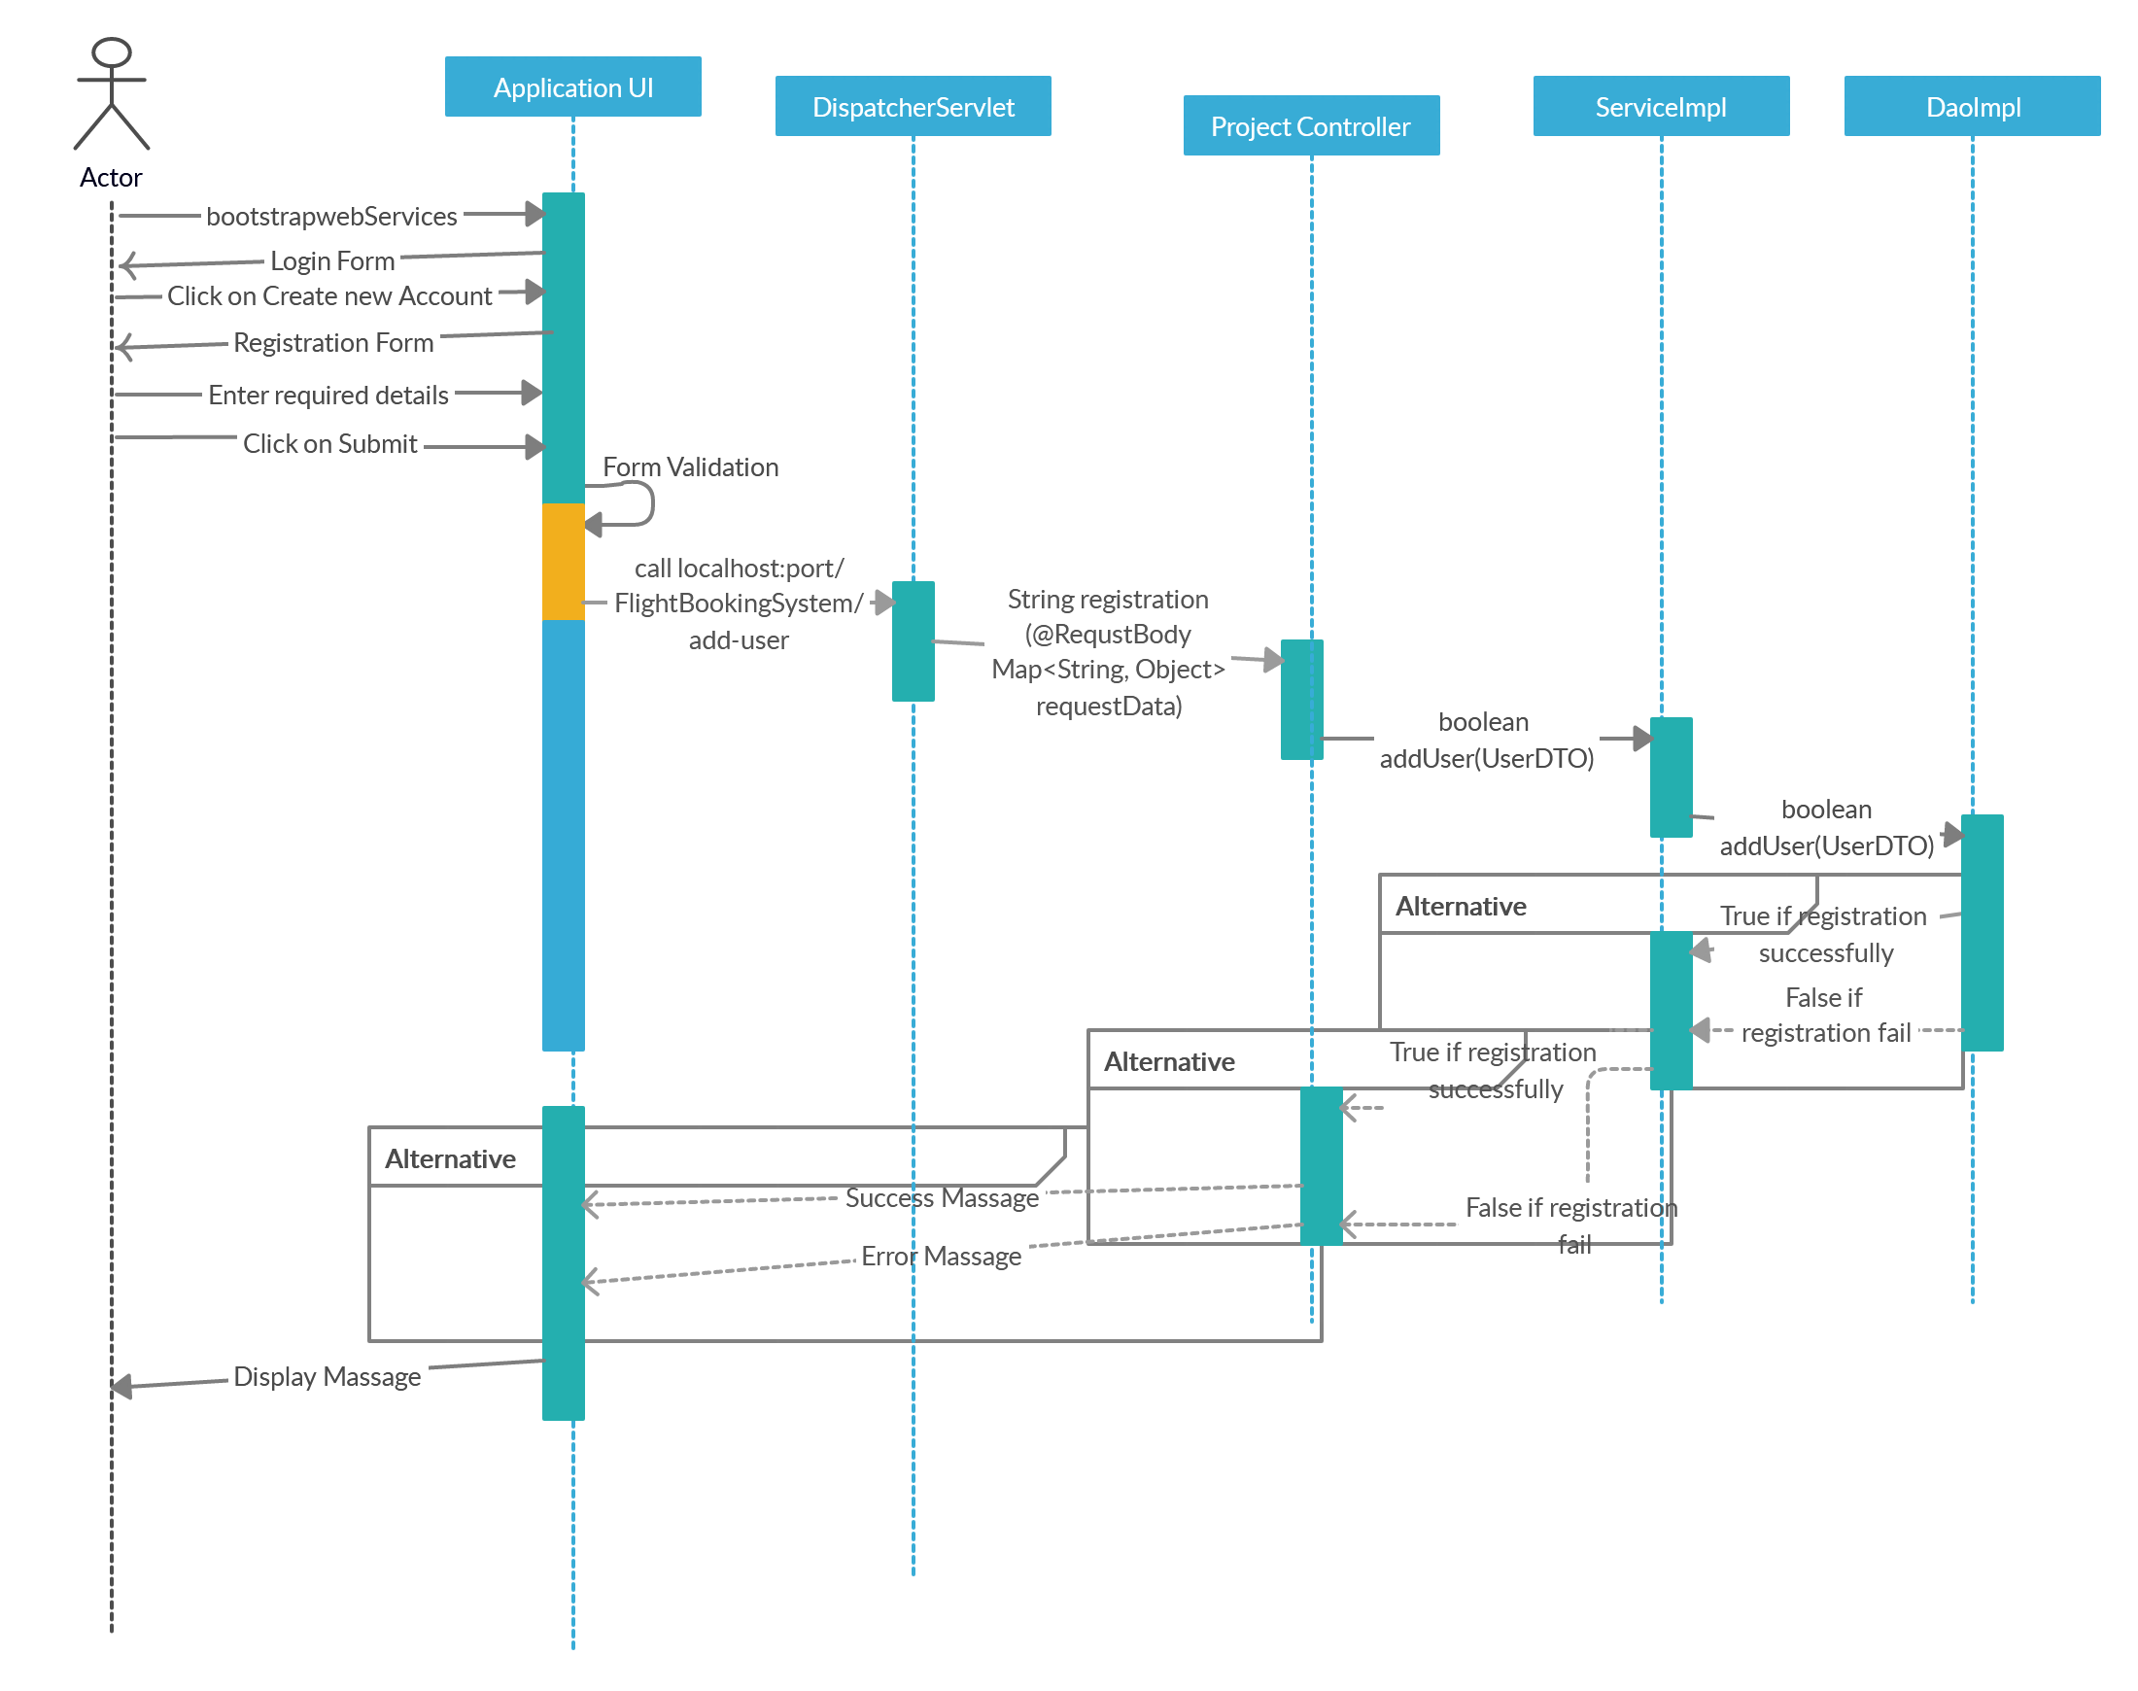

**Book Ticket:**

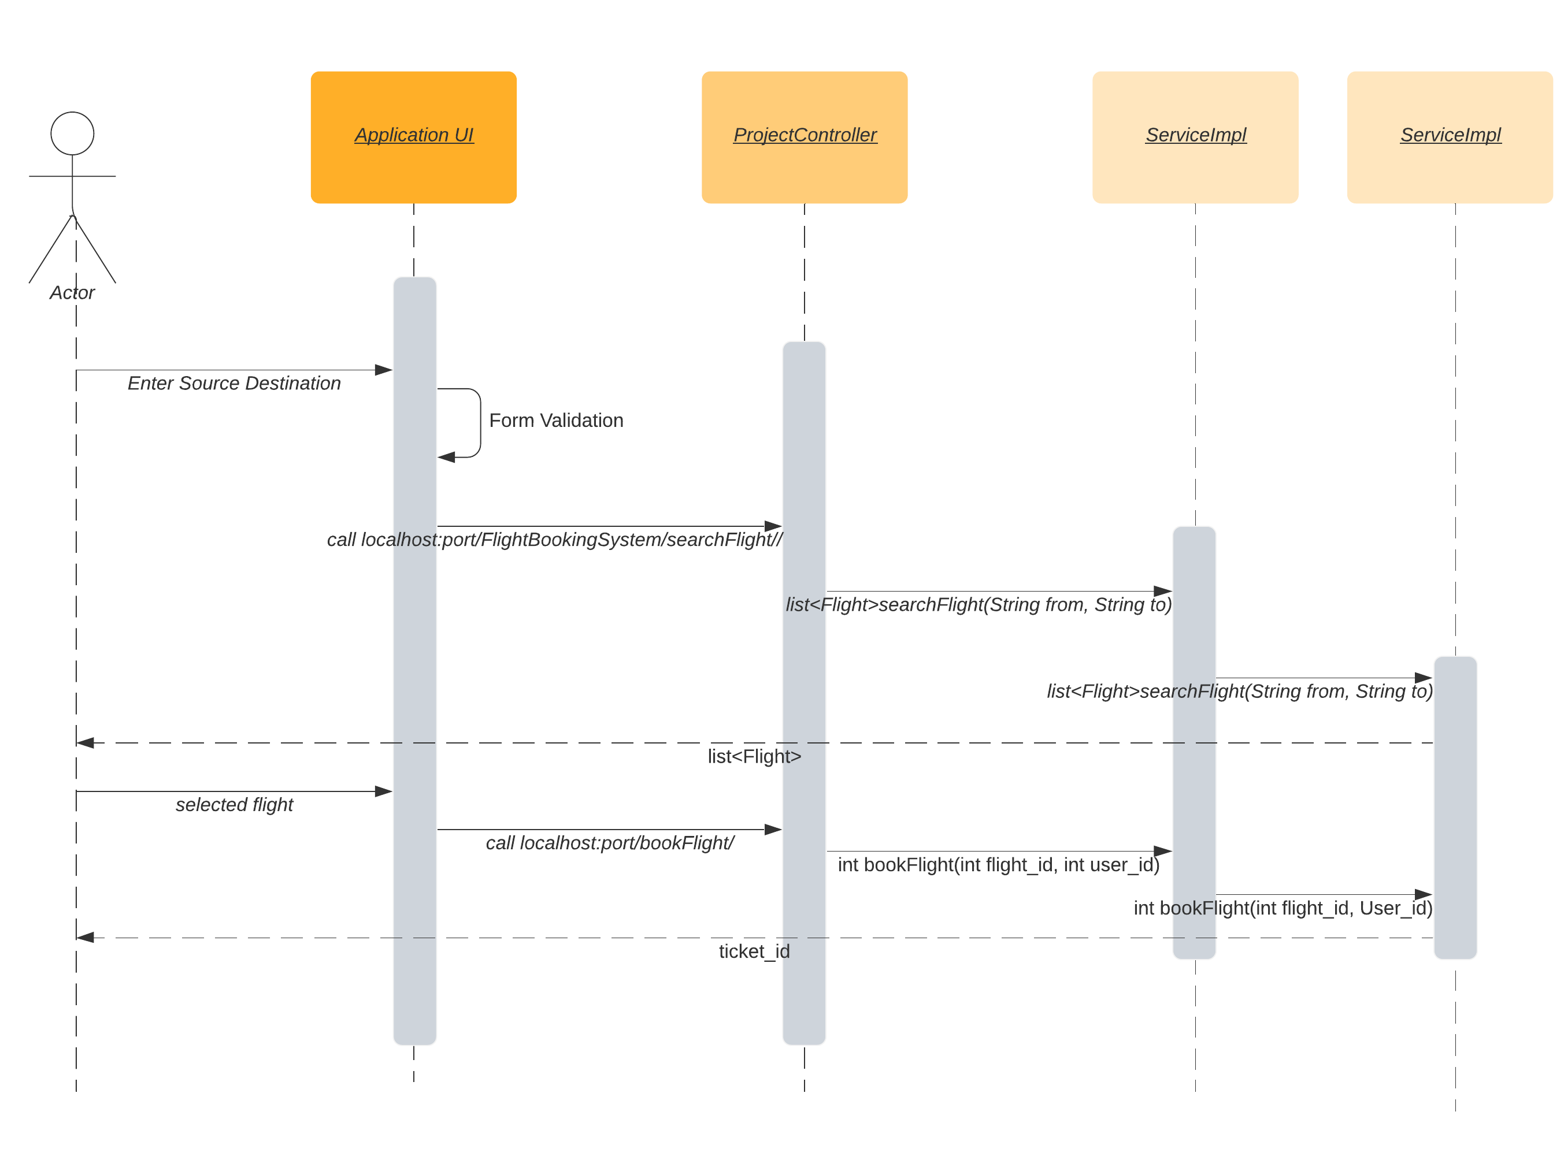

**Class Diagrams**

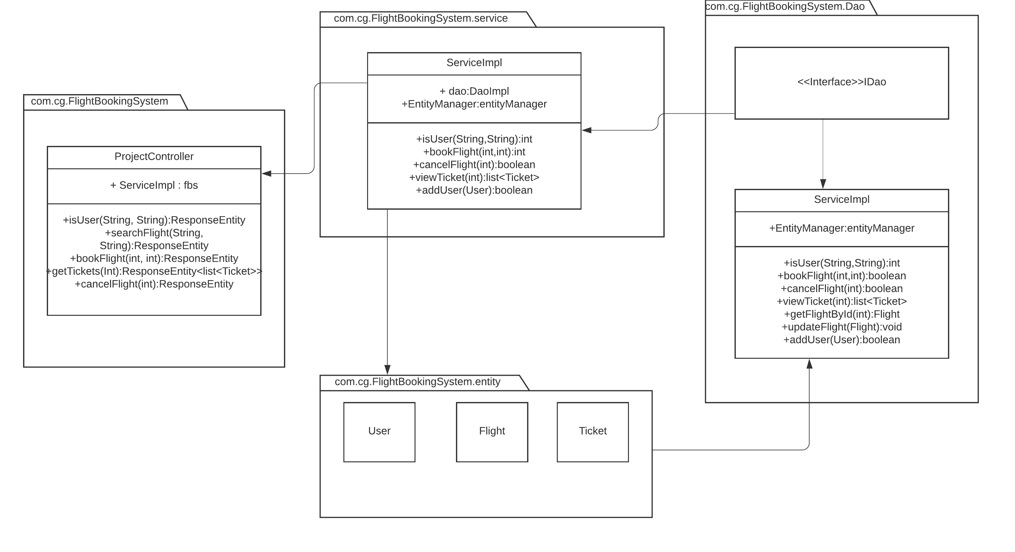

**USE Case Diagram**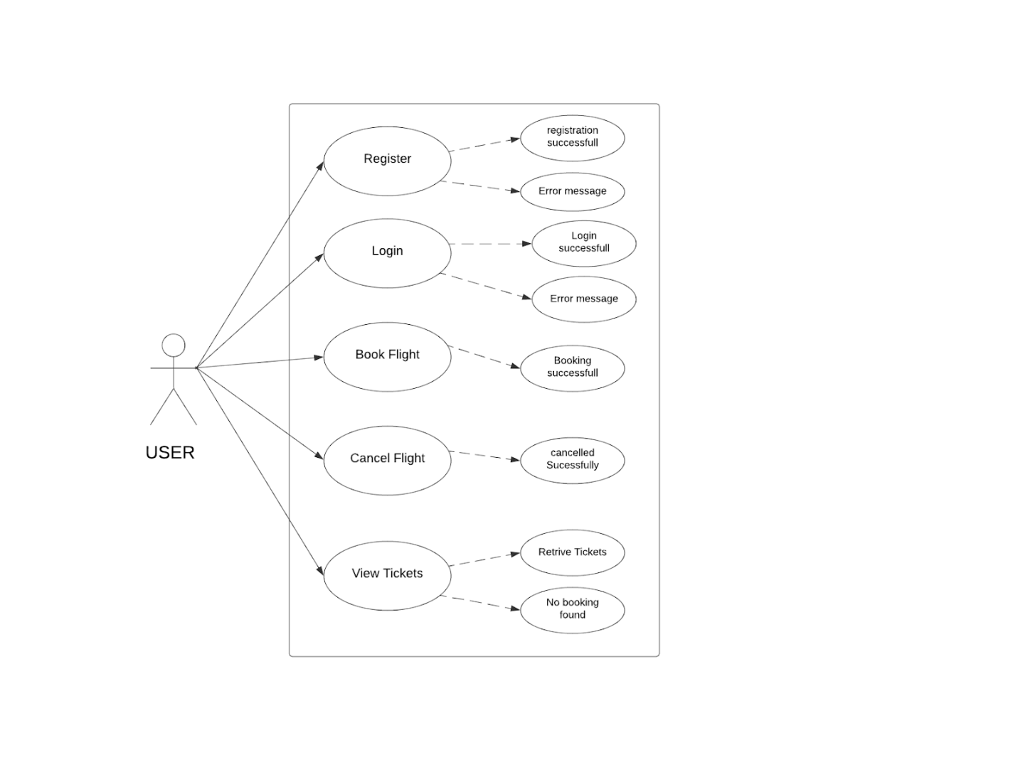

**Activity Diagrams**

**Login:**

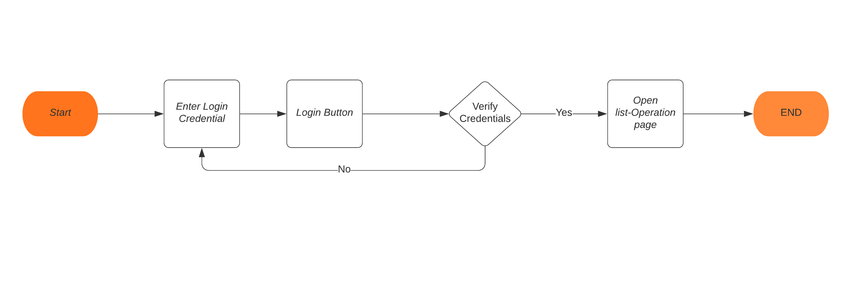

**Registration:**

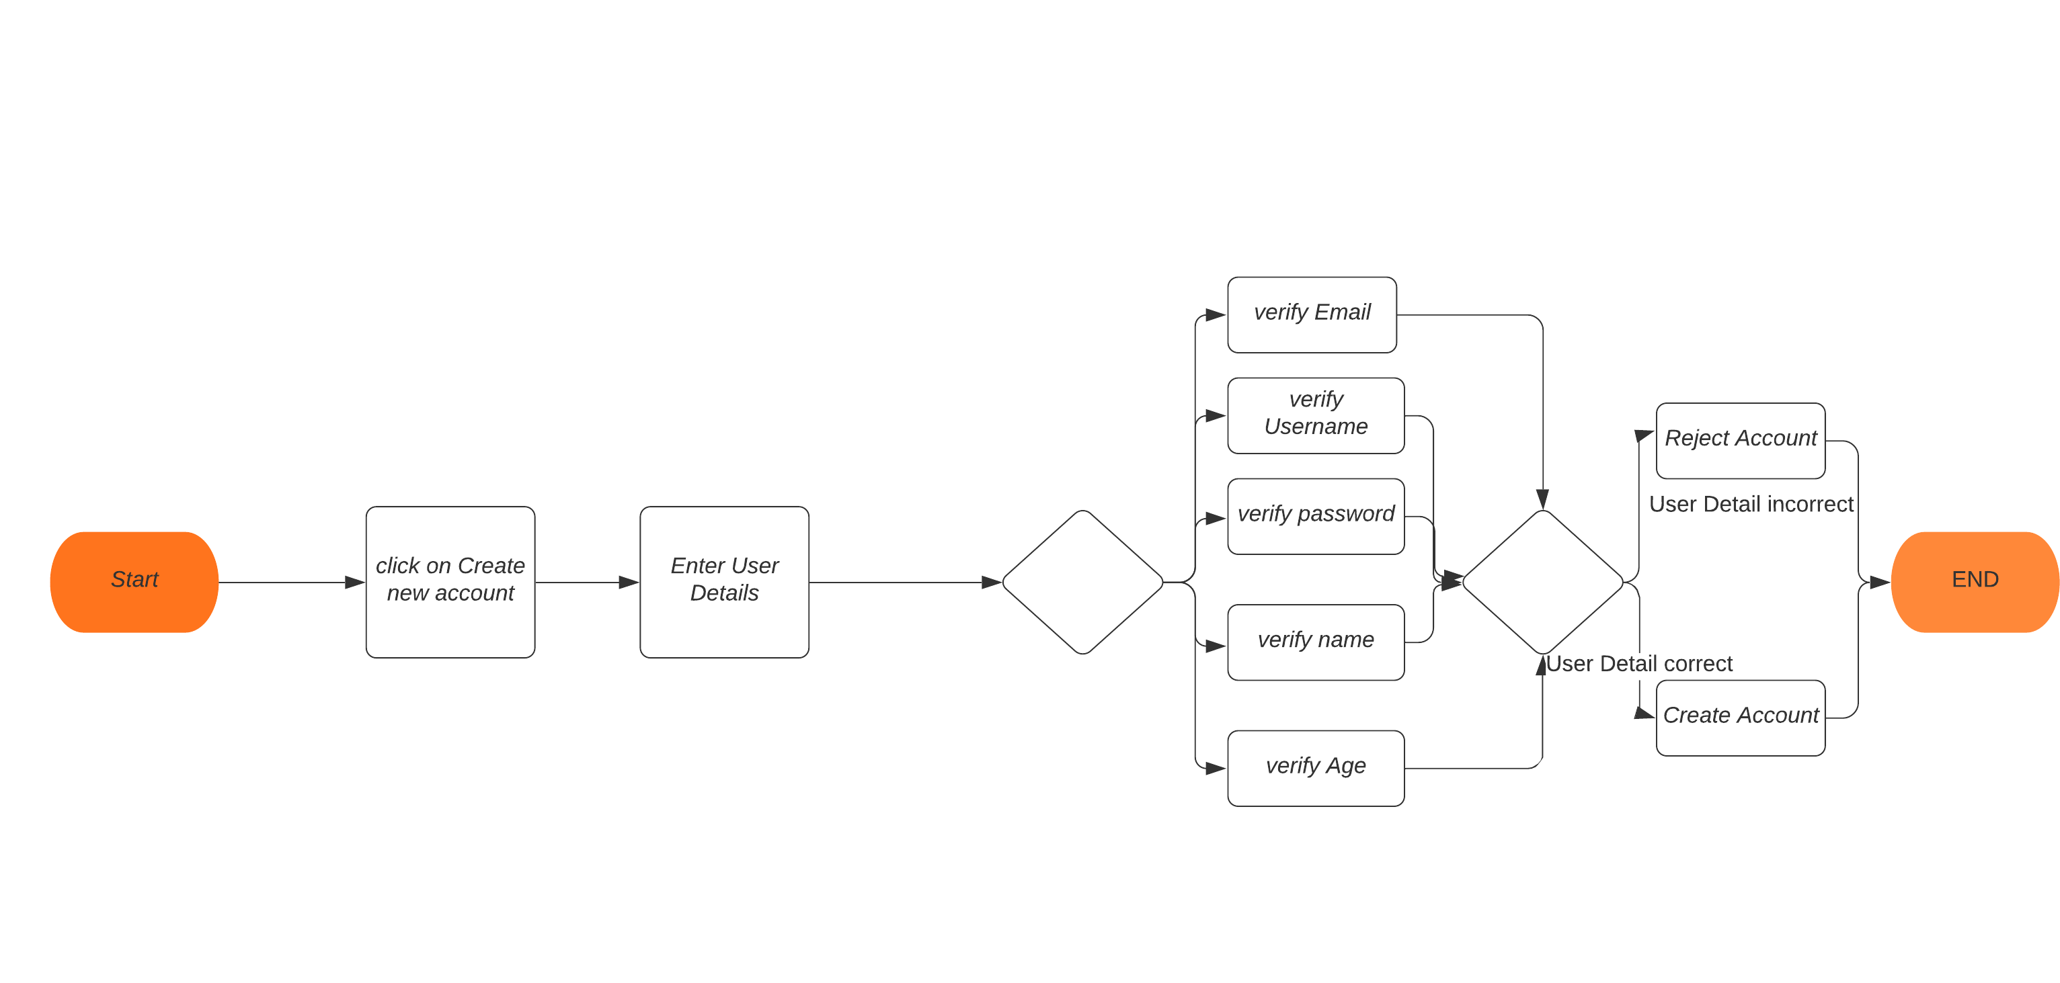

**Book Ticket:**

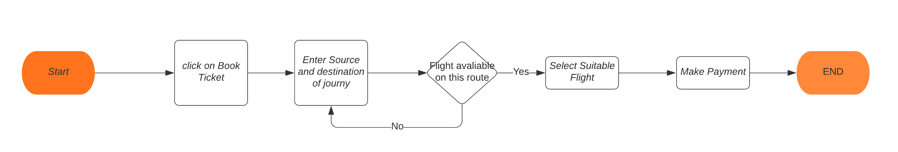

**Cancel Ticket:**

